**CLASS 26 DOCKER**



Micro :   
Cost will be high  
maintenance

LIMITATION OF MONOLITHIC:  
1. SERVER PERFORMANCE

CONTAINERS:

SERVER = CONTAINER 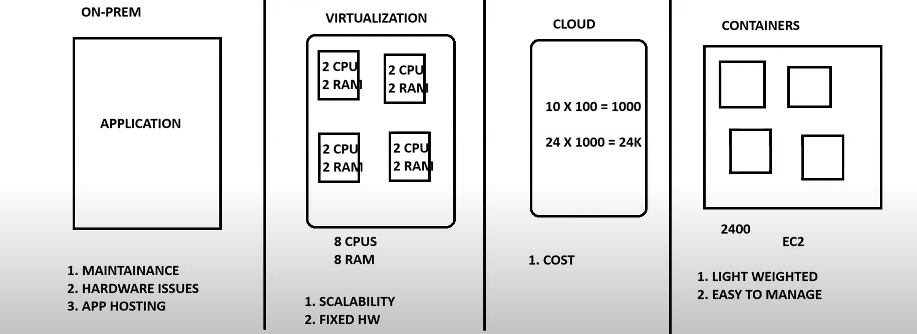  
THAT’S WHY WE USE CONTAINERS

  
for that purpose, we use images

**Images**: inside the image we have os and packages  
image(os) -- > container (app)

**Virtualization**: process of utilization hardware resources in better.

**Containerization**: Process of packing application with its dependencies. ex-

DOCKER :

It’s a free and open source platform.   
Docker will create containers .   
We can create, run, and deploy our apps on container.  
its platform independent (native runs on linux distribution) .  
cotainers will use hosts resources (cpu, mem, ram, os) .  
docker will perform os level of VIRTIUALIZATION called as containerization .  
docker is written on Go Lang

Architecture: 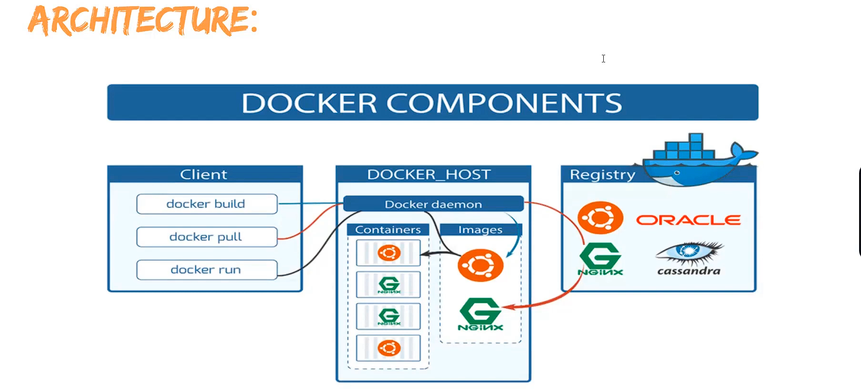client: it’s a way of interacting with docker (command- ->op)  
Docker Daemon: it manage all the docker components (images, cont., volumes, nlw)  
Docker Host: where we installed docker  
Docker Registry: it manage all the docker images on internet

 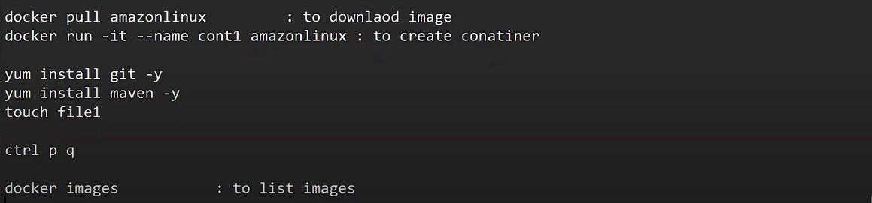 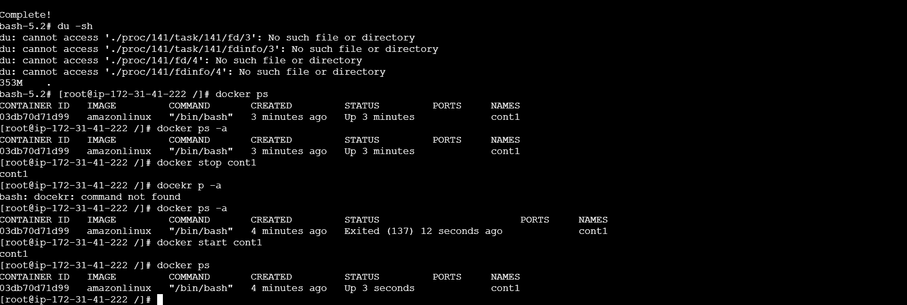

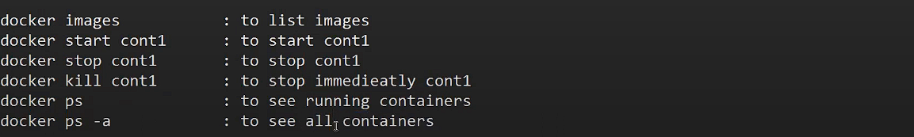

Docker stop vs kill : stop will wait for sevices inside container to stop but kill don’t care about it   
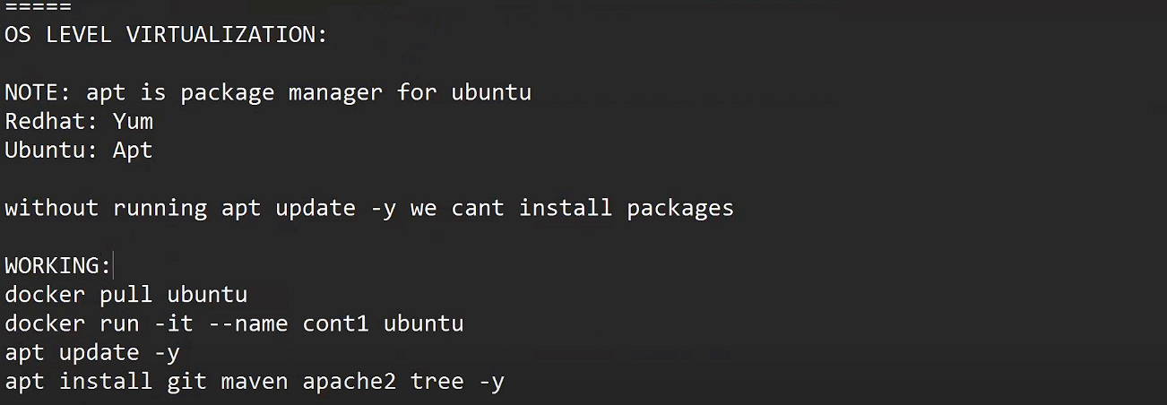  
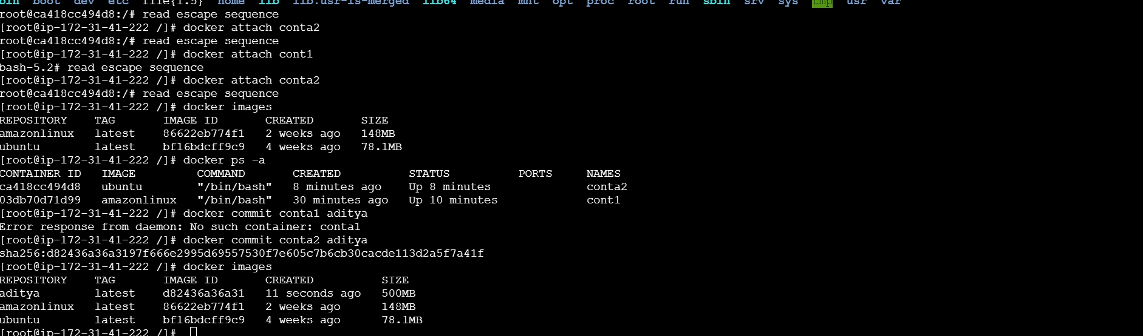 check version now

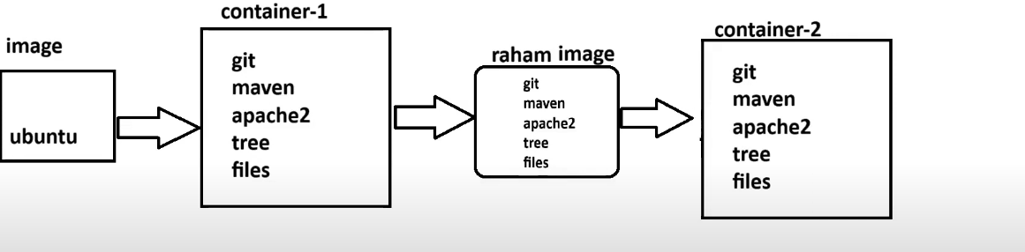here raham is an image a custom image which is made from cont1 and then in image raham if we make a container it will all the packages installed already  
DOCKERFILE : 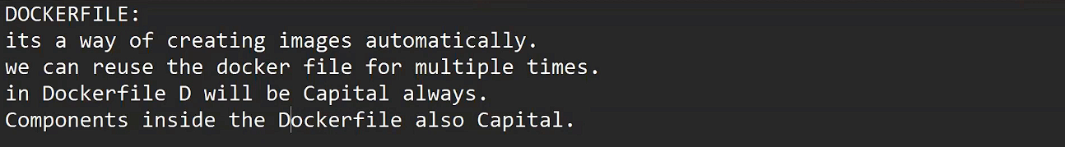  

 Ex1: 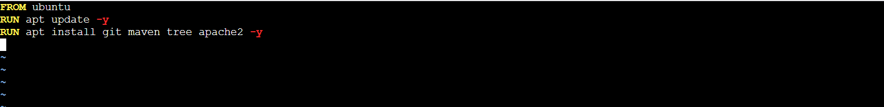 

Ex2: 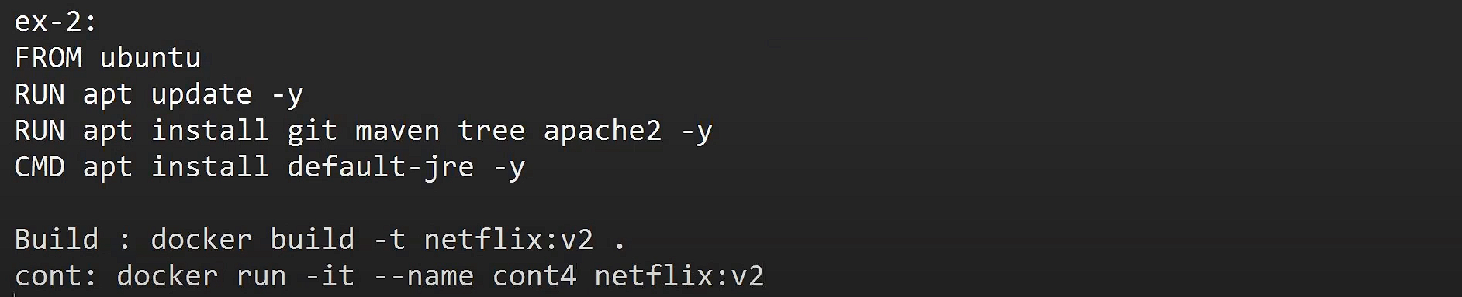    
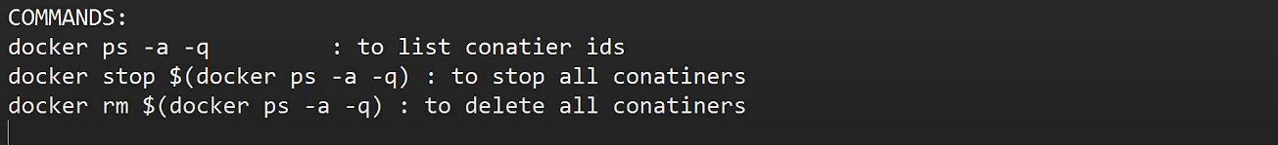same we can do for images too

Ex3 :   
make sure you make file using vim index.html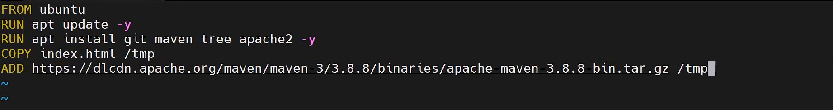

Ex4: 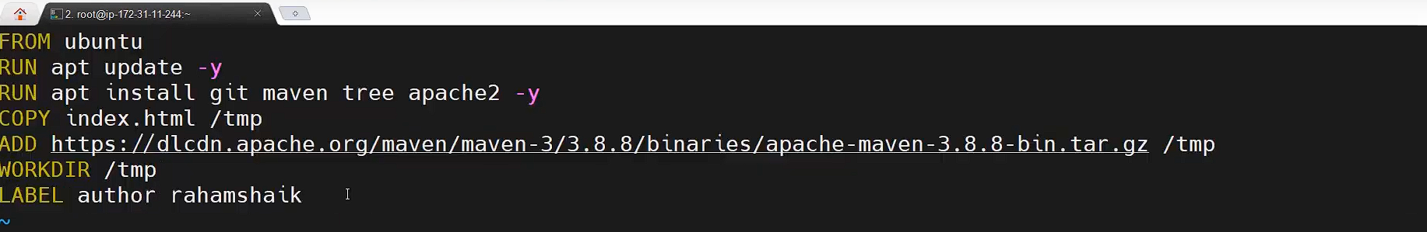docker build -t netflix:v3 .  
create container  
  
docker inspect cont7 : it will show labels in information of a container

Ex5: 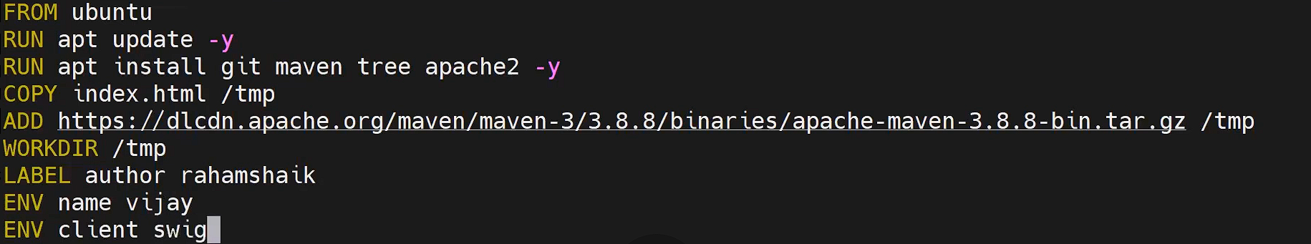 run commands inside container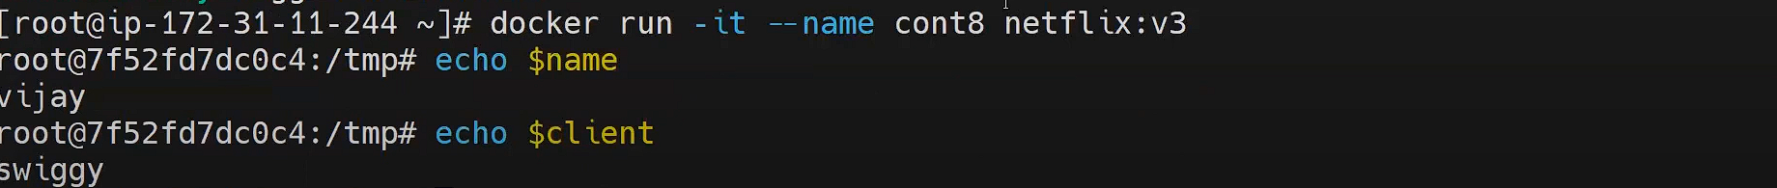

Class 28

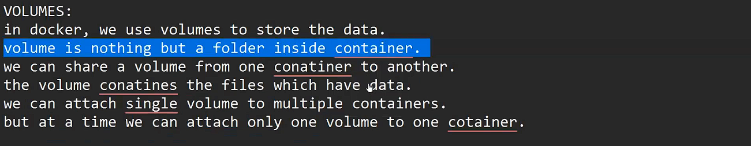volume are decoupled (loosly atached) – if you delete a container volume will not delete  
note – run the server in mobaXterm 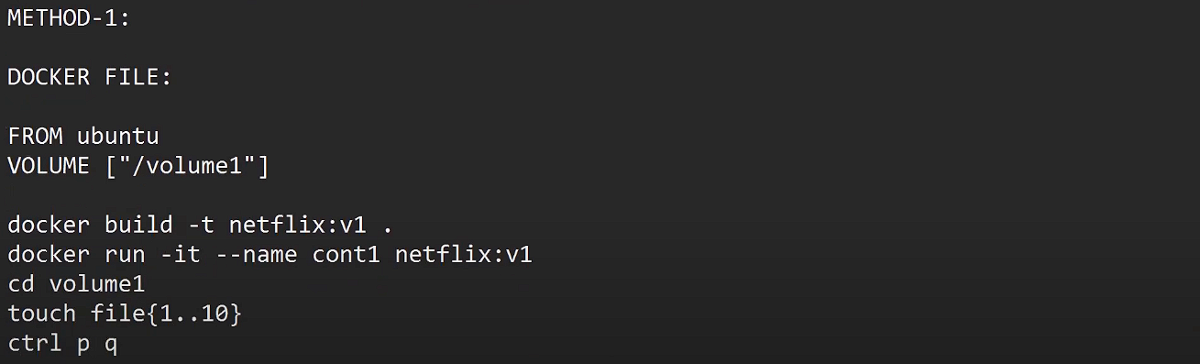it will create a cont2 and alsos copy the volume

Metod 2 : create a volume using CLI  
type the command of creating a cont but in between add one more command  
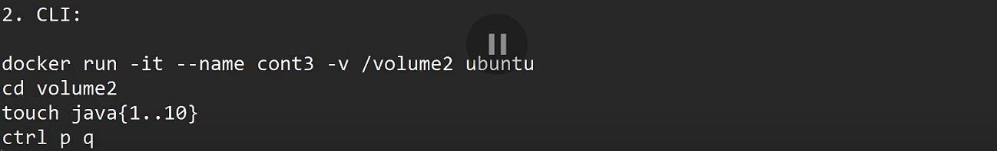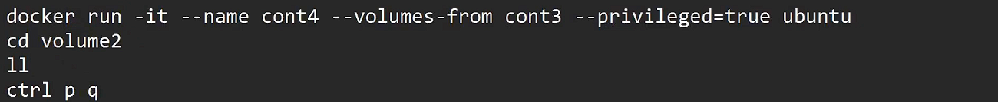

**Method3 : imp**  
VOLUME MOUNTING :

Volume commands:  
docker volume create volume3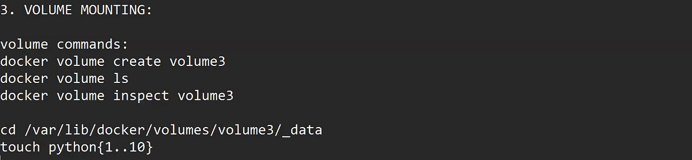

**Method 4 :** Moving files from local to container :  
create a container and attach a volume for it (eg- cont6)

Cntr p q  
create files   
touch aditya{1..10}  
docker inspect cont6 – it will show you which volume is attached in it and its path copy it or  
docker volume inspect volume4 – copy the path   
cp * /var/lib/docker/volumes/volume4/_data – copy all file to that path  
now got to cont6 – docker attach cont6   
ll - you will see the file

**Method 5: **

**SYSTEM COMMANDS:**   
1. docker system df – to show docker components resource utilization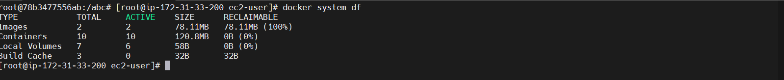

JENKINS SETUP :

docker run -it - -name cont1 -p 8080:8080 jenkins/jenkins:lts  
here by single command you can setup jenkins  
  
CLASS 29

DEPLOYING A WEBSITE  
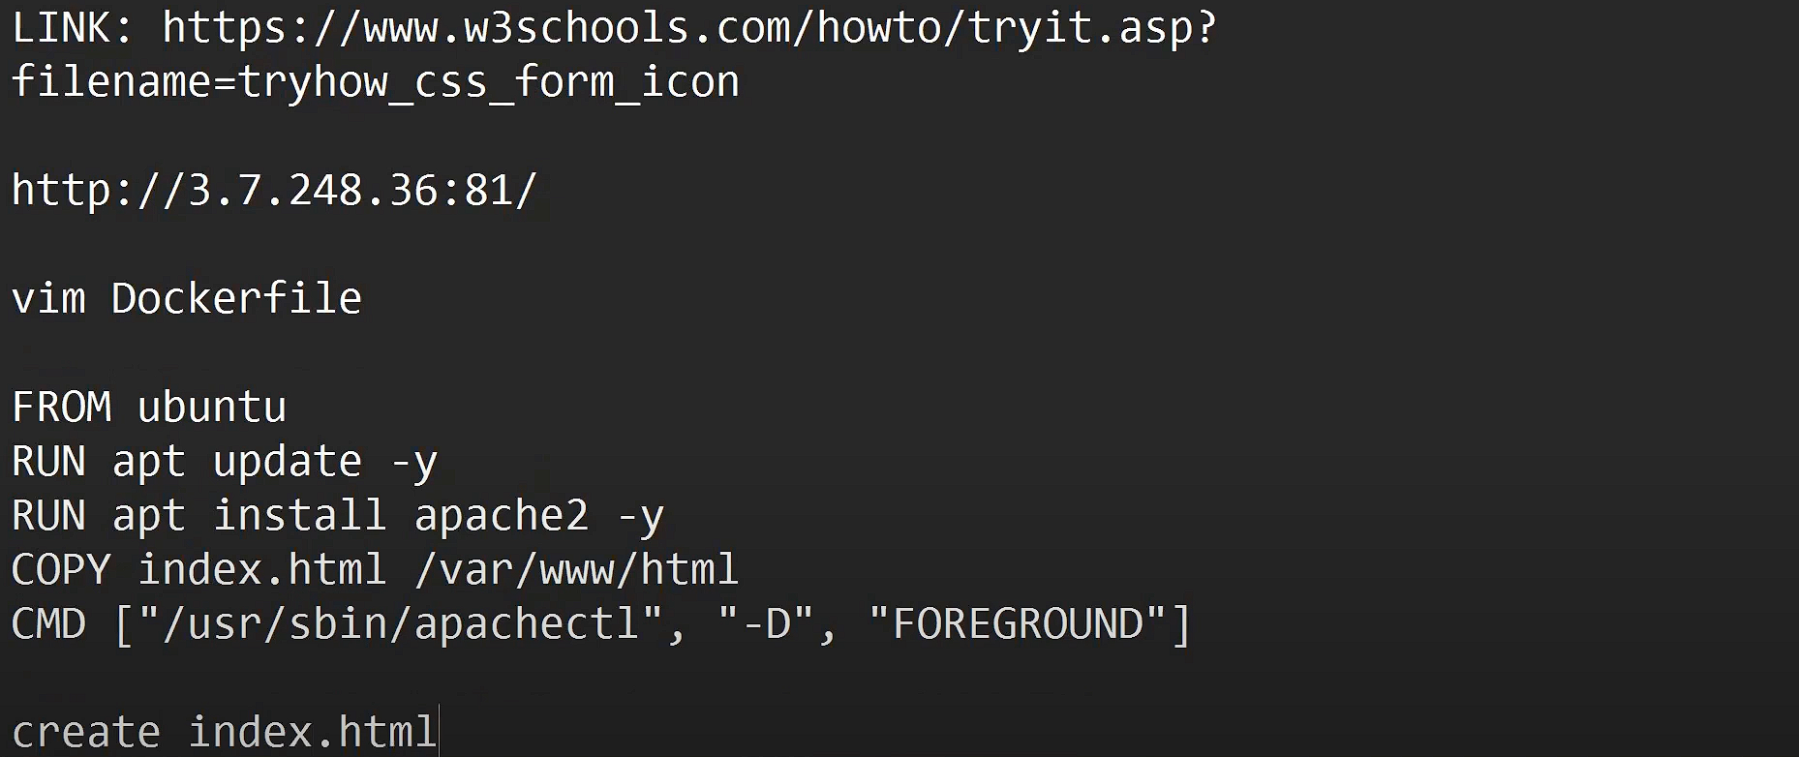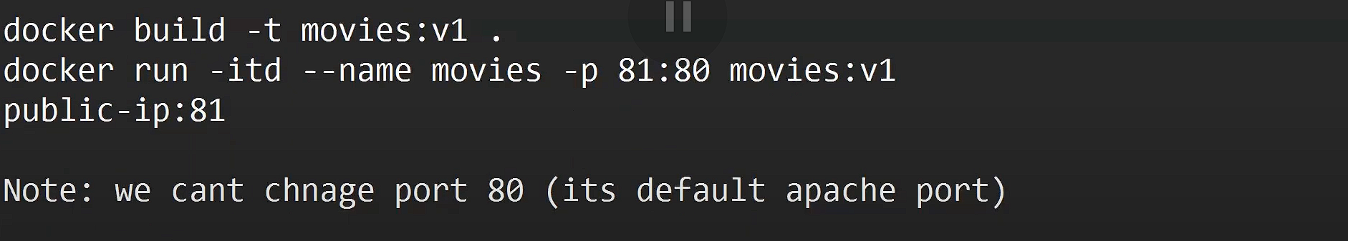

Now by this process we can create multiple apps by changing index.html code and port no  
but but but this is not a perfect way to deploy application coz its manual  
now we will use Docker Compose

DOCKER COMPOSE: 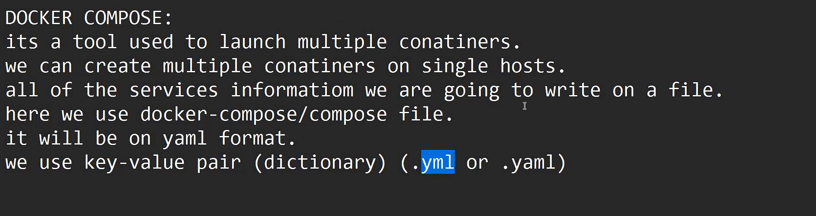used to manage multiple services with the help of a file  
SETUP: 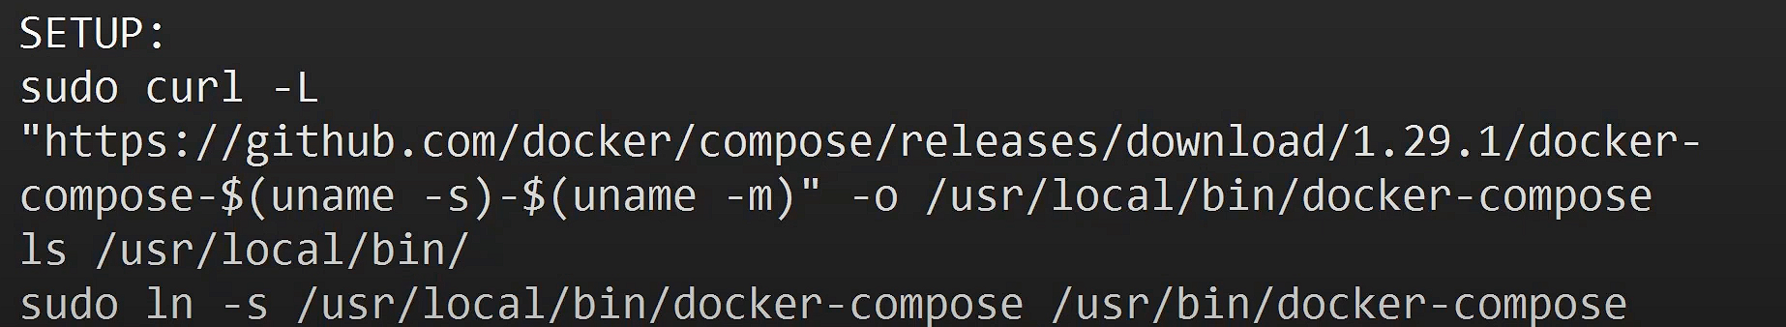docker-compose version  
vim docker-compose.yml  
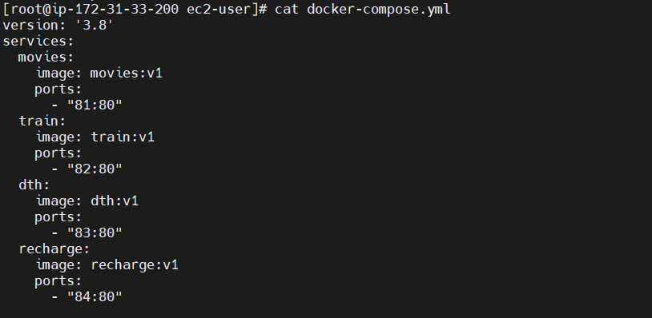  
Note : remove all the manually build containers

Commands:   
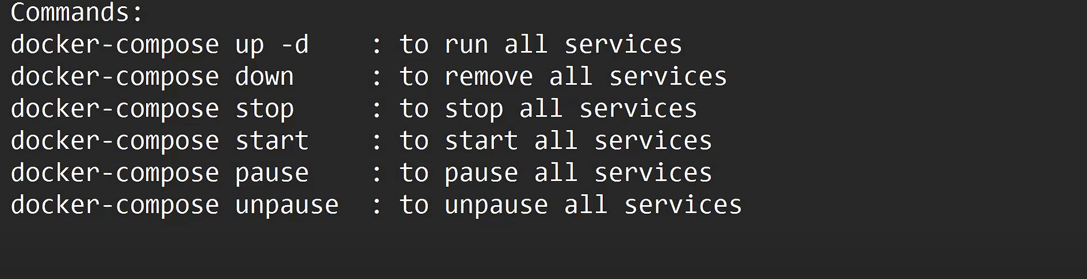  
docker-compose logs : to get all logs managed by compose files  
docker-compose kill : to kill all services -stop without waiting   
docker-compose top : to get all process managed by containers on compose file

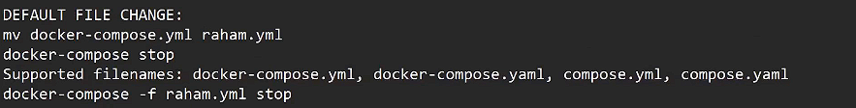  
docker-compose run all the containers on single host but if it gets deleted we will lot everything  
for that purpose docker swarn came .

CLASS 30

DOCKER HUB : It’s a centra platform used to store the docker images .  
image we create on hosts then we will push them to dockerhub .  
Once image is available on dockerhub we can use in any server .  
we use repos to store images .  
repo types : 1. Public 2. Private repo  
  
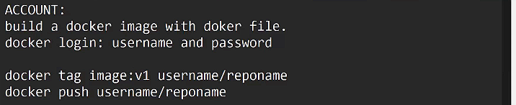

DOCKER SWARM :   
High Availability : Deployin gap on more than one server means using the cluster .

Docekr swarn is an acontainer orchesstration tool . it is used to manage multiple containers on multiple nodes. Each nodes will have a copy of single container. Here we all have manager node and worker nodes. Manager node will create containers and esnt to eorker nodes.   
worker odes will take the container and manage them .   
  
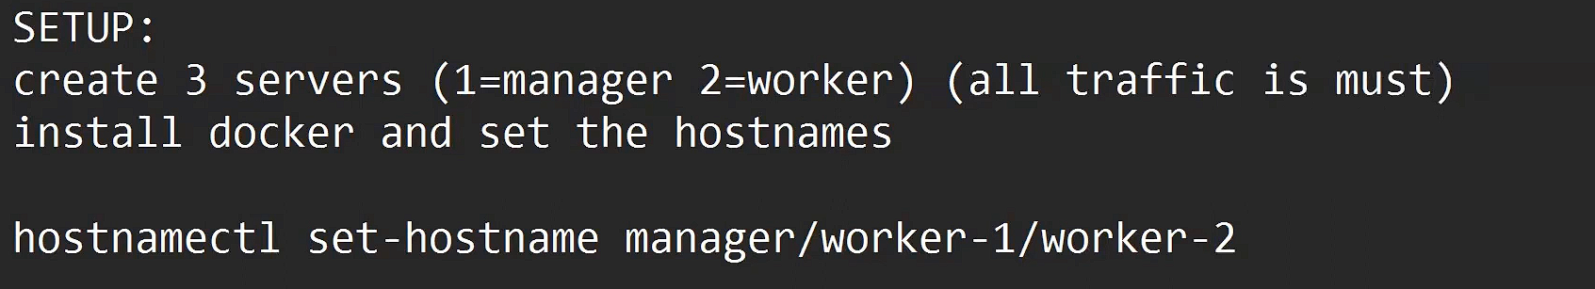  
manager node : docker swarm init  
copy the tocken to all worker nodes  
  
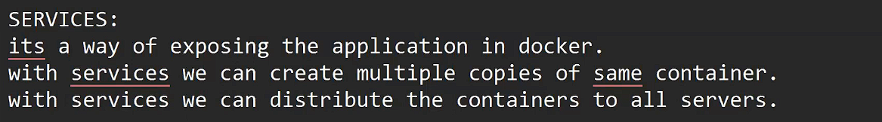  
docker service create --name movies --replicas=3 --publish 81:80 adityasinghio/movies:latest  
docker service create --name trains --replicas=3 --publish 82:80 adityasinghio/tarin:latest

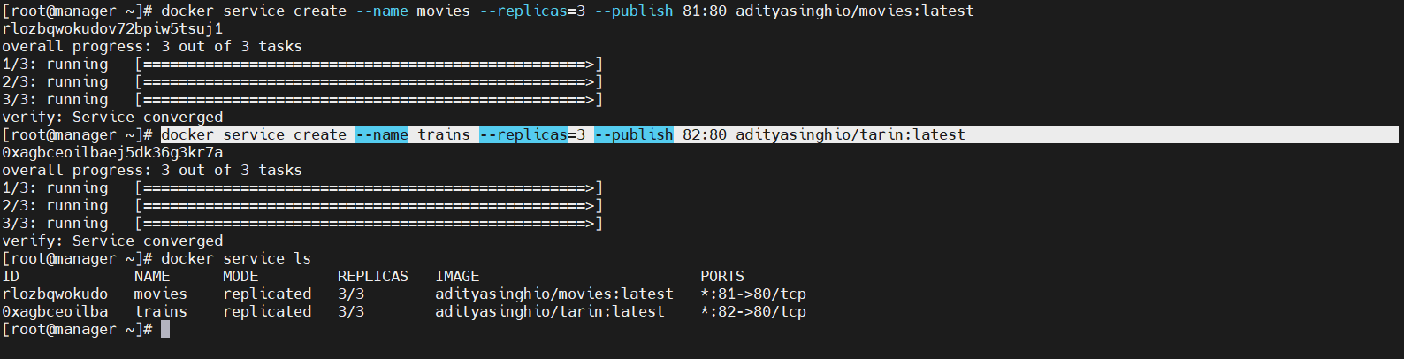now the container is created in all node sand you can check by enetring ip address with port no  
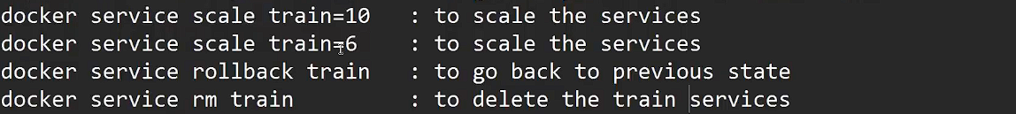

  
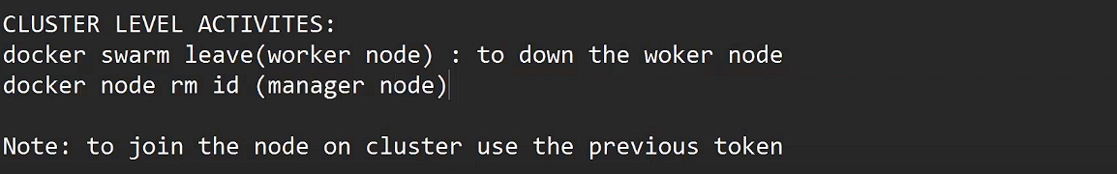

to retreave the tocken  
